Going for a greener look?
With energy prices on the rise and a greater awareness of their environmental impact, more churches are looking at green energy options for longer-term sustainable and efficient heating and lighting solutions for their buildings.
At Baptist Building CIO, our loans to Baptist churches include green energy projects, whether as a standalone solution or as part of a bigger build. So if you’re looking to upgrade your lighting to efficient LEDs, improve your heating systems by installing air source heat pumps or reduce your reliance on the grid with solar panels, we would like to help.
We offer loans of £30,000+, repayable over 10 years*. We don’t charge interest but do expect a thank-offering donation once the loan is repaid, to cover our administration costs and to help us to help other churches. We want to enable you to expand, repair and improve your church premises to make a difference in your communities, and that includes your environmental impact. So if you need capital funding to help make your green project a reality, speak to us at Baptist Building CIO.
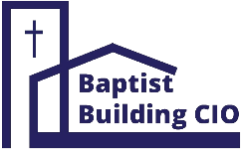
Email us at admin@baptistbuilding.org or call us on 07506663761
*for more detail on the qualifying criteria and terms and conditions of our loans, please visit our website : www.baptistbuilding.org/our-loans

